**Experiment -** Design a Night Lamp.

**Circuit Diagram**:

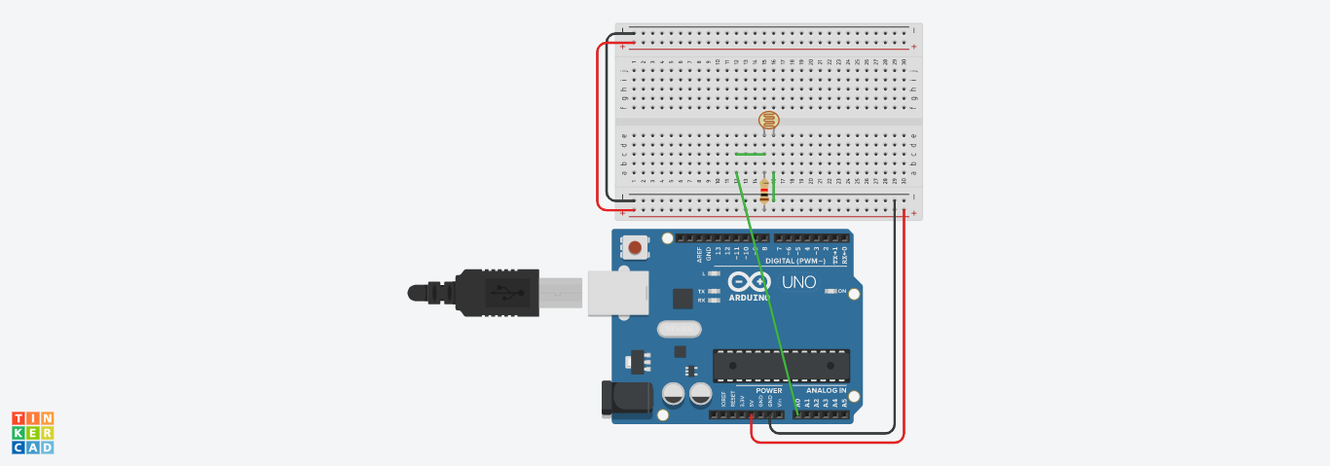

**Theory**:

An LED is a small light (it stands for "light emitting diode") that works with relatively little power. The Arduino board has one built-in on digital pin 13. LEDs have polarity, which means they will only light up if you orient the legs properly. The long leg is typically positive, and should connect to a digital pin on the Arduino board. The short leg goes to GND; the bulb of the LED will also typically have a flat edge on this side.

**Learning and observation :**

The led turns on and off for 1 second each i.e., it blinks after every second.

Since 1000ms equals 1 second.

Arduinos are programmed via USB connections.

**Problems and troubleshooting:**

1. Not selecting the correct port.

2. Improper connections.

**Precautions:**

1. Wiring should be proper.
2. Proper port should be choosed.
3. Problem uploading to arduino.

**Learning outcomes:**

The led turns on and off for 1 second each i.e., it blinks after every second.

Since 1000ms equals 1 second.

Arduinos are programmed via USB connections.